NAME: K Yamini
REG NO: 192572181

Write a Python program to solve the Water Jug problem using Breadth First Search (BFS)
Aim:
To find a sequence of steps to measure a desired amount of water using two jugs of given capacities.
Algorithm:
- Start with an empty 8×8 chessboard.
- Place a queen in the first column.
- Check if the queen placement is safe:
- No queen in the same row
- No queen in the same column
- No queen in diagonal positions
If safe, move to the next column.
Repeat the process for all columns.
If placing a queen leads to conflict:
Backtrack (remove queen)
- Try next row
- Continue until all 8 queens are placed.
- Print the final board configuration.
Python Code:
from collections import deque
# Function to solve Water Jug problem
def water_jug_bfs(jug1, jug2, target):
visited = set()
queue = deque()
queue.append((0, 0, [])) # (jug1, jug2, path)
while queue:
x, y, path = queue.popleft()
# If already visited
if (x, y) in visited:
continue
visited.add((x, y))
path = path + [(x, y)]
# Check if target reached
if x == target or y == target:
return path
# Possible operations
next_states = [
(jug1, y), # Fill Jug1
(x, jug2), # Fill Jug2
(0, y), # Empty Jug1
(x, 0), # Empty Jug2
# Pour Jug1 → Jug2
(x - min(x, jug2 - y), y + min(x, jug2 - y)),
# Pour Jug2 → Jug1
(x + min(y, jug1 - x), y - min(y, jug1 - x))
]
for state in next_states:
if state not in visited:
queue.append((state[0], state[1], path))
return None
# Input
jug1 = 4
jug2 = 3
target = 2
# Solve
solution = water_jug_bfs(jug1, jug2, target)
# Output
print("Initial State: (0, 0)\n")
print("Steps to reach target:\n")
step = 1
for (x, y) in solution:
print("Step", step, ":", (x, y))
# Comments in output
if step == 1:
print("# Fill Jug2")
elif step == 2:
print("# Pour Jug2 → Jug1")
elif step == 3:
print("# Fill Jug2 again")
elif step == 4:
print("# Pour Jug2 → Jug1 until full")
print()
step += 1
print("Target Achieved!")
Input:
Jug1 Capacity = 4L
Jug2 Capacity = 3L
Target = 2L
Output :
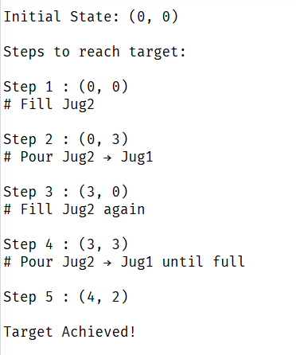
Result:
The Water Jug problem is solved successfully using BFS, and the target amount is obtained step-by-step.

